Logbook Week 2
January 20, 2026

On the second week we solved some pending principle of operation issues with the steps of our assembly line:
- The biggest thing we did this week figuring out and committing to a mechanism principle of operation for rolling up the sushi. We decided on a ribcage style design that will be powered by a motor on one axis, with the other axis going the opposite direction through sawtooth gears on the inner end:

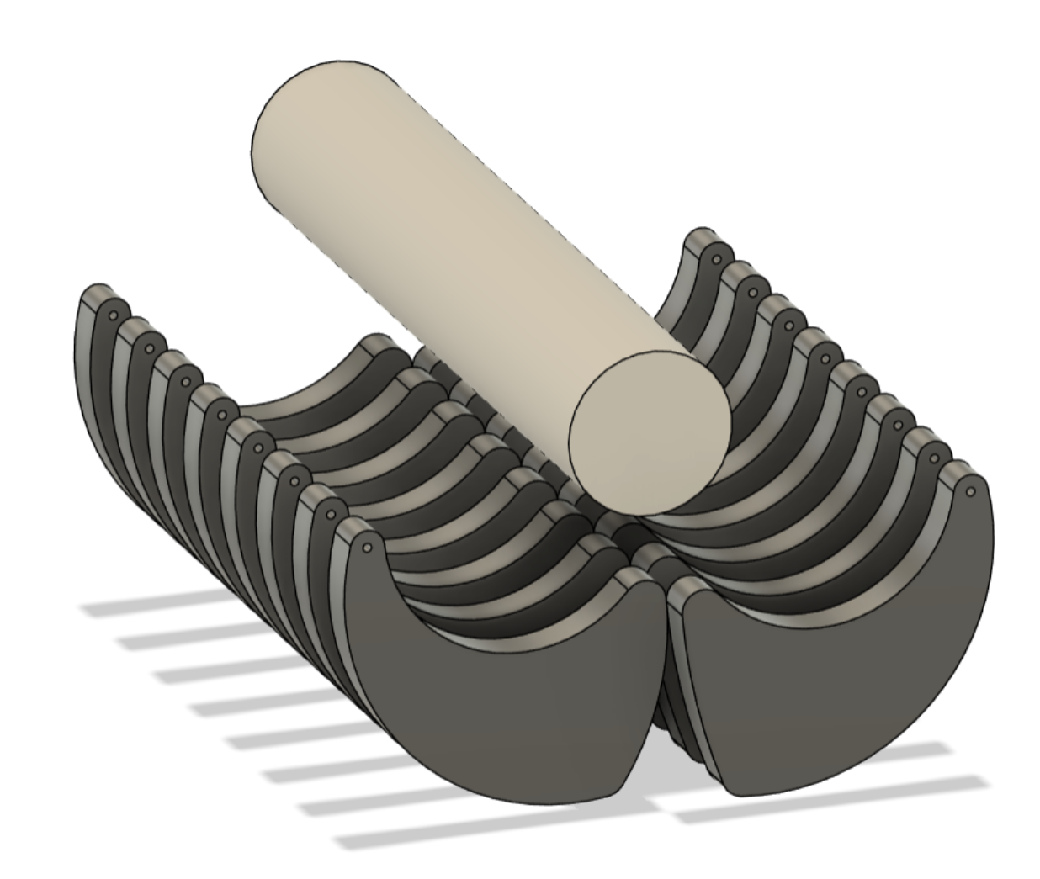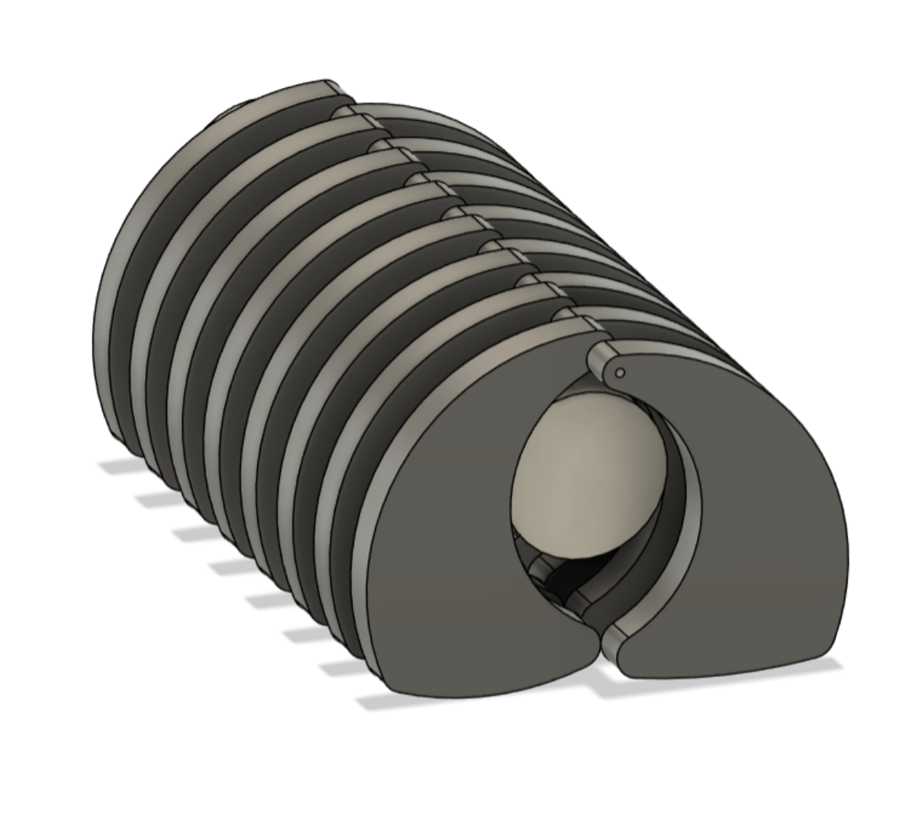
This is an early prototype design and we still have to plan the size of the roller and thing being rolled, and if the platform the ribcage roller will be under will have grooves built-in so the ribs can make it through to roll the sushi.
- Another big thing we did this week was figuring out a principle of operation for dispensing the sticky rice. We took inspiration from sushi machines already out there that uses a series of rollers to flatten the rice and then output it as a layer sheet for the sushi:
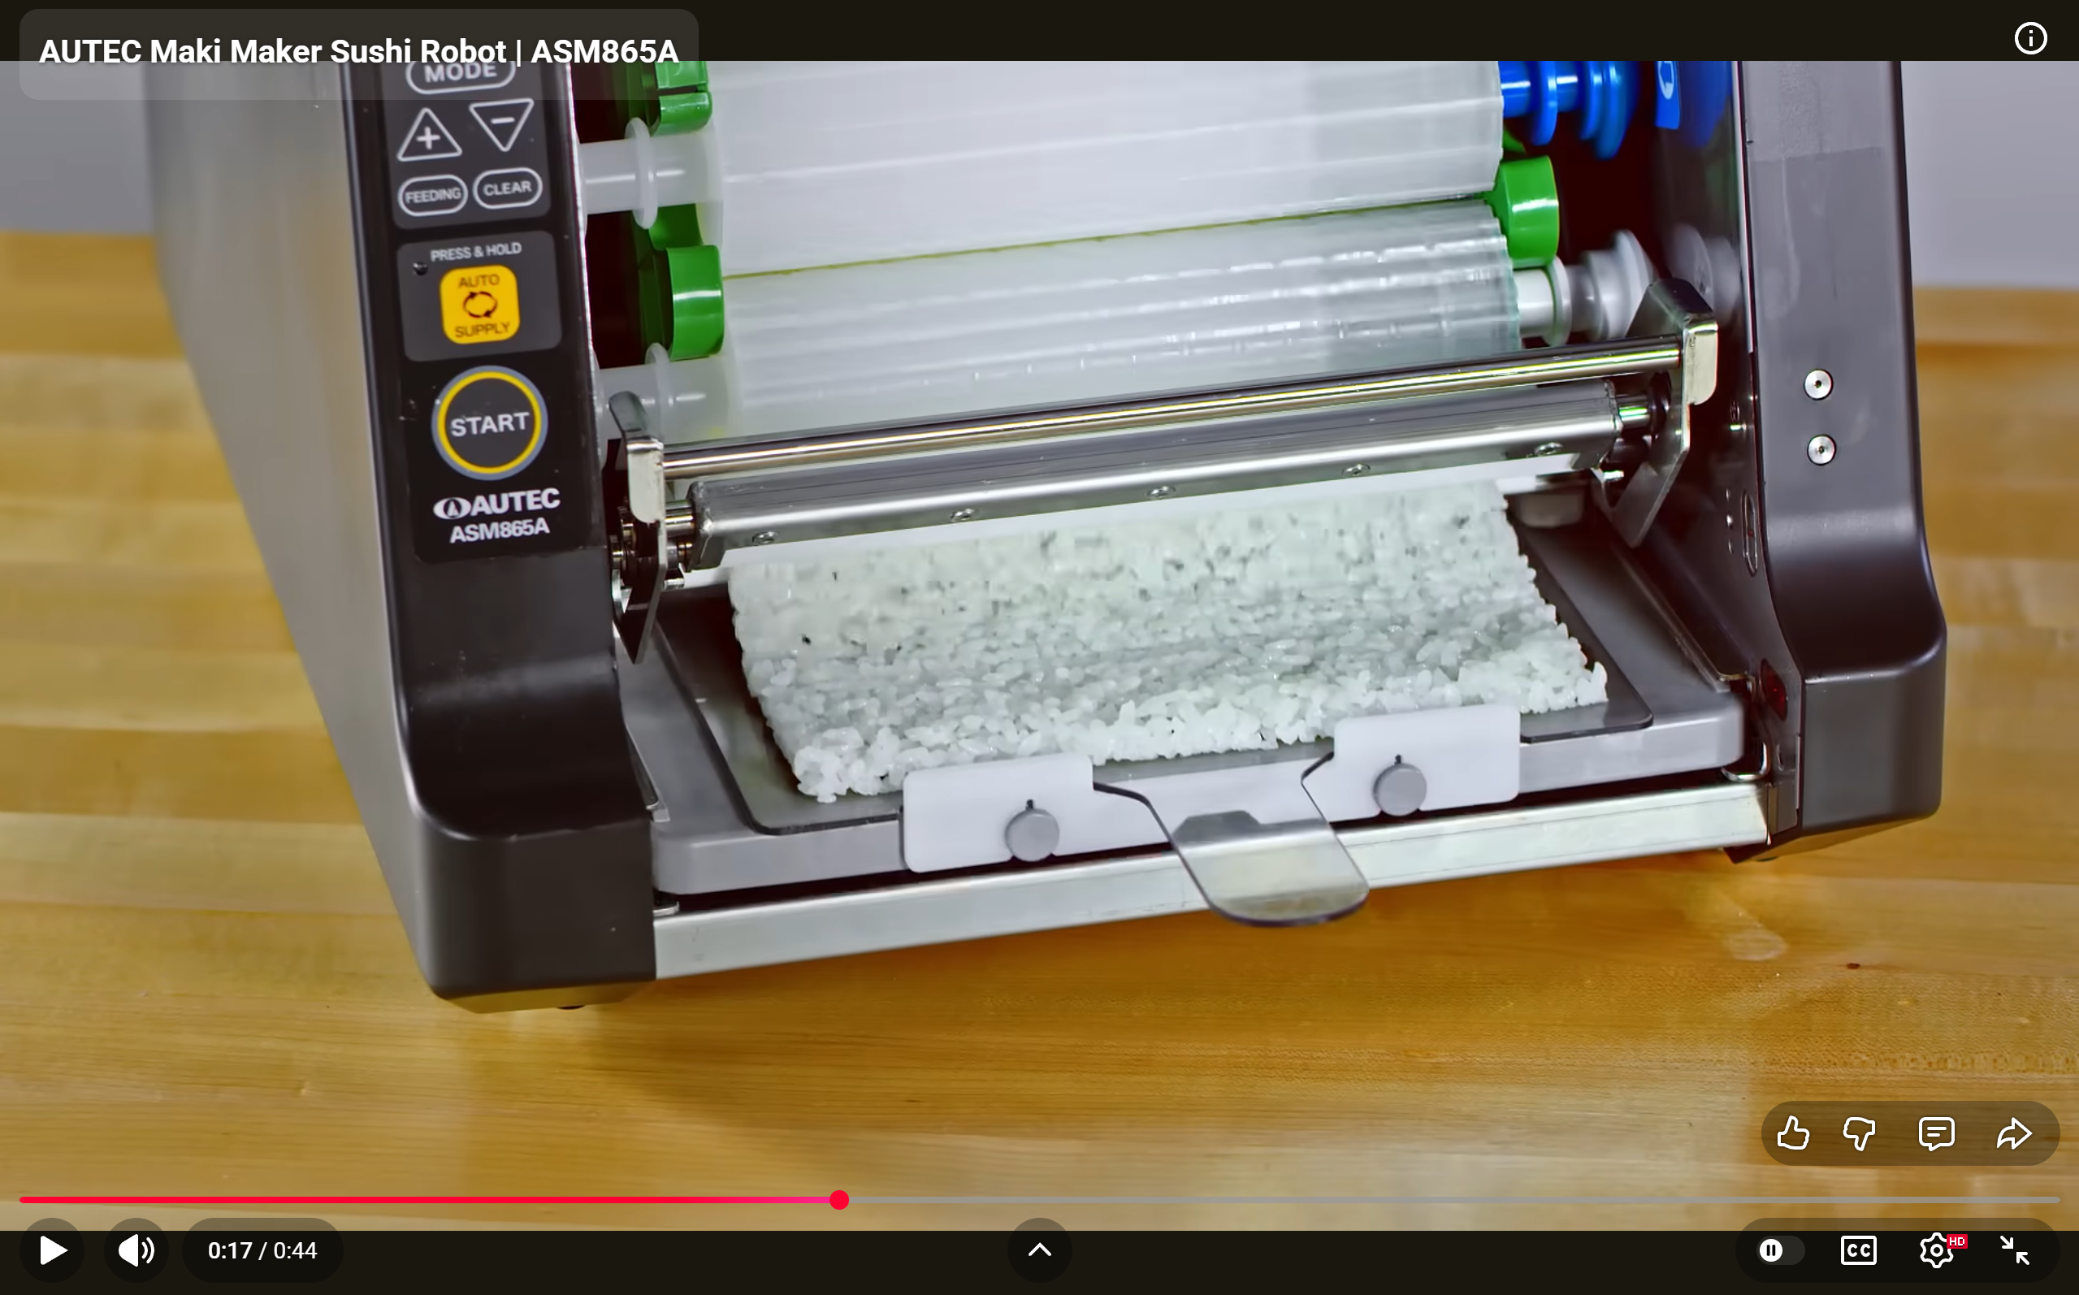
- The blade for slicing the sushi is also the simplest part but we did make some progress on its design. We decided on a guillotine-type blade for better slicing, multiple blades mounted on one line, and it will go straight down to cut the sushi.

- This is a general plan for the assembly line that we came up with, and the steps:
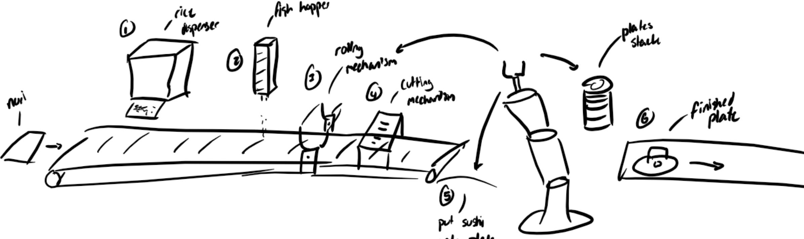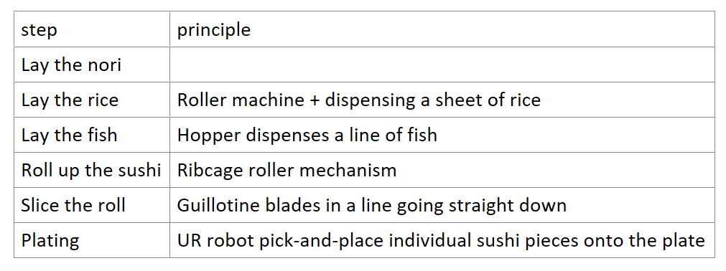
We are still deciding if we want the user to manually place the nori at the start of the conveyor or if we’re going to make another machine to do it.

An update for the robot: We have access to a UR3e robot along with its controller, both mounted on a table, which we plan to mount the whole assembly line on as well.
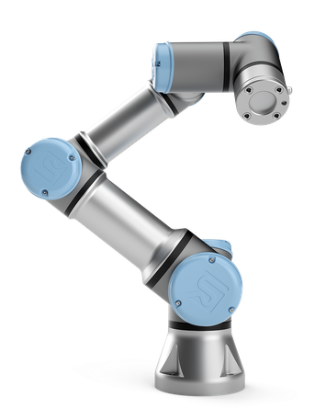

Things we will work on next week:
- This week we plan to meet up or call to finish our presentation slides and proposal. Honestly, I was having anxieties/doubts about our idea because we didn’t have any finalized principles of operation for the assembly line, and I wasn’t 100% confident we would be able to get the project done. But now that we spent this week innovating and thinking of ideas to solve those issues, I am very confident we can get this done
- We will present our slides and submit our proposal next week as well
- Jamie plans to continue prototyping the ribcage roller on CAD and maybe even 3D-printing it to test it on simple things
- Jacob and I plan to start calculating the forces we need for each step and figuring out the requirements for each motor, how many motors we need, and start shopping for motors
- All three of us will continue designing the mechanisms for each step and adding stuff to our shared OneNote notebook and Google Drive
- We also want to learn how to control the UR robot but that is last priority because we’re thinking of using it as a final pick-and-place for plating the sushi professionally (to impress the audience). We will still need to figure out how to interface it with our main controller

